Chapter 19
Valuation and Financial Modeling:
A Case Study
19-1. You would like to compare Ideko’s profitability to its competitors’ profitability using the EBITDA/sales multiple. Given Ideko’s current sales of $75 million, use the information in Table 19.2 to compute a range of EBITDA for Ideko assuming it is run as profitably as its competitors.
Ideko’s 2005 sales are $75 million.
Find the highest and lowest EBITDA values across all three firms and the industry as a whole:
EBITDA/Sales (%) EBITDA ($ mil)
Oakley 17.0 12.75
Luxcottica 18.5 13.875
Nike 15.9 11.925
Industry 12.1 9.075
This implies an EBITDA range of $9.075 to $13.875 million.
19-2. Assume that Ideko’s market share will increase by 0.5% per year rather than the 1% used in the chapter. What production capacity will Ideko require each year? When will an expansion become necessary (when production volume will exceed the current level by 50%)?
First compute the projected annual market share:
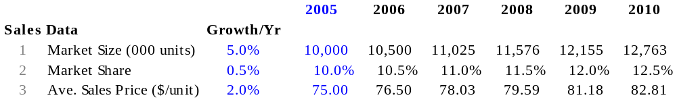
Using these projections, calculate the projected annual production volume:
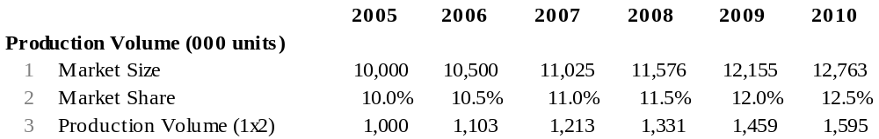
Based on these estimates, it will be 2010 before current capacity is exceeded and an expansion becomes necessary.
19-3. Under the assumption that Ideko market share will increase by 0.5% per year, you determine that the plant will require an expansion in 2010. The cost of this expansion will be $15 million. Assuming the financing of the expansion will be delayed accordingly, calculate the projected interest payments and the amount of the projected interest tax shields (assuming that the interest rates on the term loans remain the same as in the chapter) through 2010.
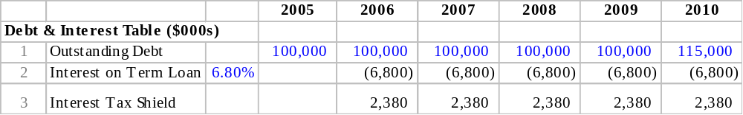

19-4. Under the assumption that Ideko’s market share will increase by 0.5% per year (and the investment and financing will be adjusted as described in Problem 3), you project the following depreciation:
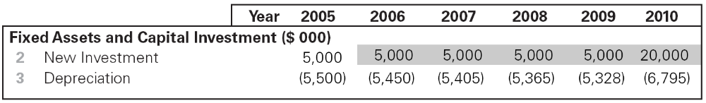
Using this information, project net income through 2010 (that is, reproduce Table 19.7 under the new assumptions).
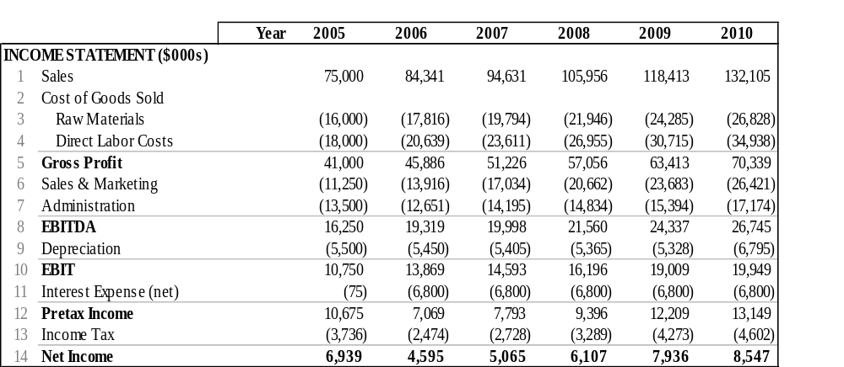
19-5. Under the assumptions that Ideko’s market share will increase by 0.5% per year (implying that the investment, financing, and depreciation will be adjusted as described in Problems 3 and 4) and that the forecasts in Table 19.8 remain the same, calculate Ideko’s working capital requirements though 2010 (that is, reproduce Table 19.9 under the new assumptions).
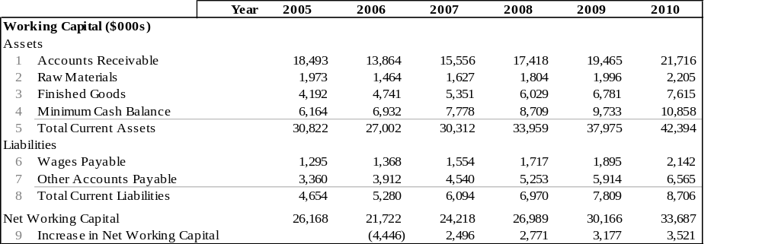
19-6. Under the assumptions that Ideko’s market share will increase by 0.5% per year (implying that the investment, financing, and depreciation will be adjusted as described in Problems 3 and 4) but that the projected improvements in net working capital do not transpire (so the numbers in Table 19.8 remain at their 2005 levels through 2010), calculate Ideko’s working capital requirements though 2010 (that is, reproduce Table 19.9 under these assumptions).
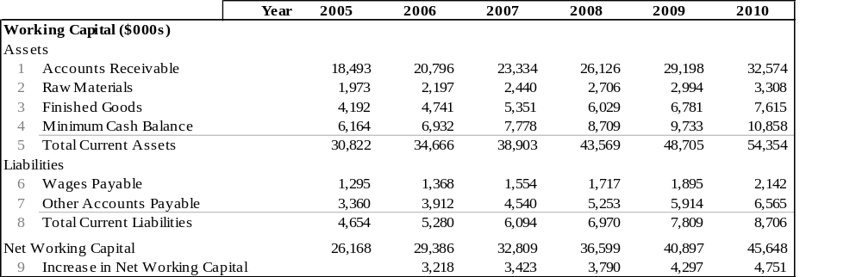
19-7. Forecast Ideko’s free cash flow (reproduce Table 19.10), assuming Ideko’s market share will increase by 0.5% per year; investment, financing, and depreciation will be adjusted accordingly; and the projected improvements in working capital occur (that is, under the assumptions in Problem 5).
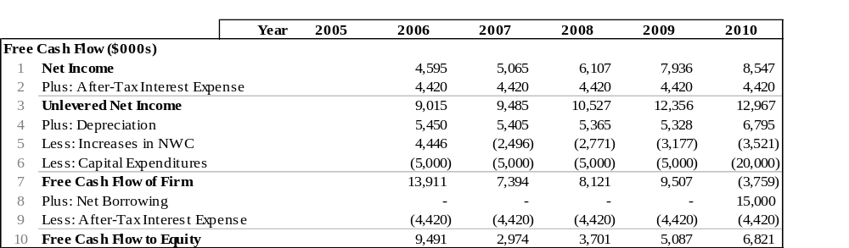
19-8. Forecast Ideko’s free cash flow (reproduce Table 19.10), assuming Ideko’s market share will increase by 0.5% per year; investment, financing, and depreciation will be adjusted accordingly; and the projected improvements in working capital do not occur (that is, under the assumptions in Problem 6).
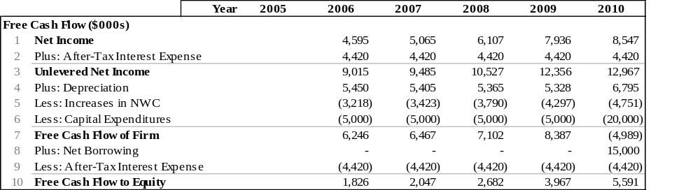
19-9. Reproduce Ideko’s balance sheet and statement of cash flows, assuming Ideko’s market share will increase by 0.5% per year; investment, financing, and depreciation will be adjusted accordingly; and the projected improvements in working capital occur (that is, under the assumptions in Problem 5).
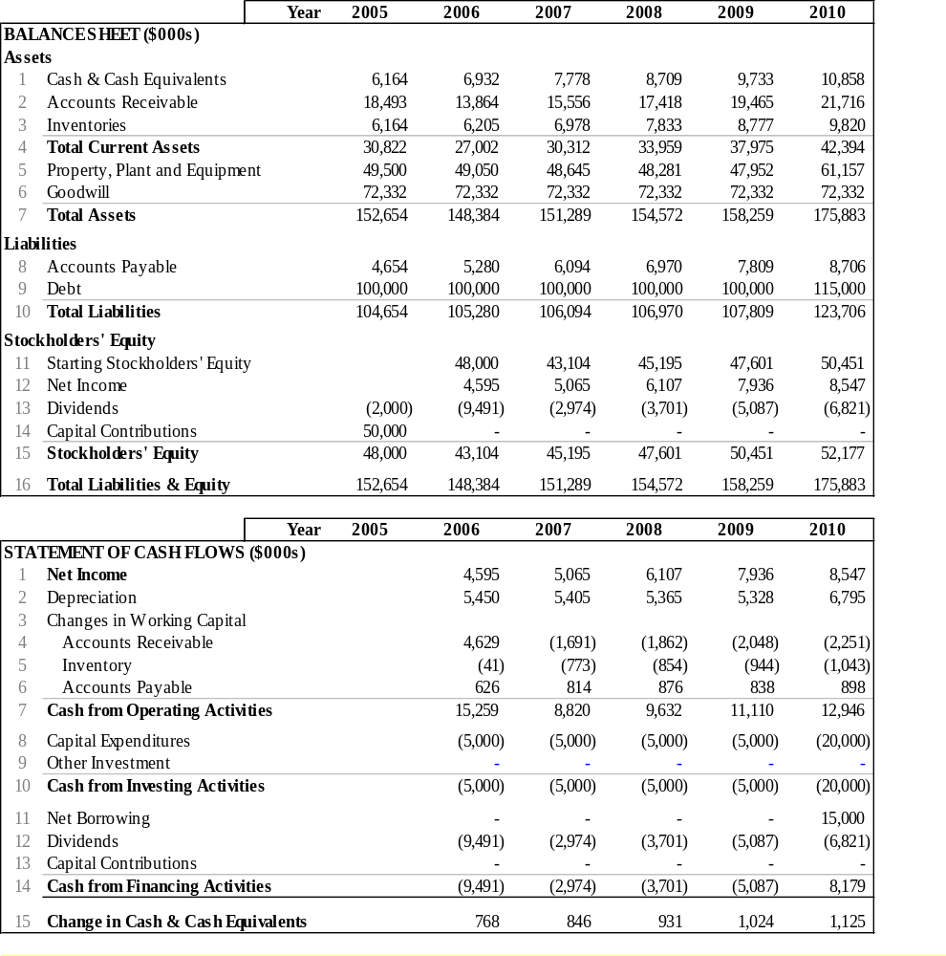
19-10. Reproduce Ideko’s balance sheet and statement of cash flows, assuming Ideko’s market share will increase by 0.5% per year; investment, financing, and depreciation will be adjusted accordingly; and the projected improvements in working capital do not occur (that is, under the assumptions in Problem 6).
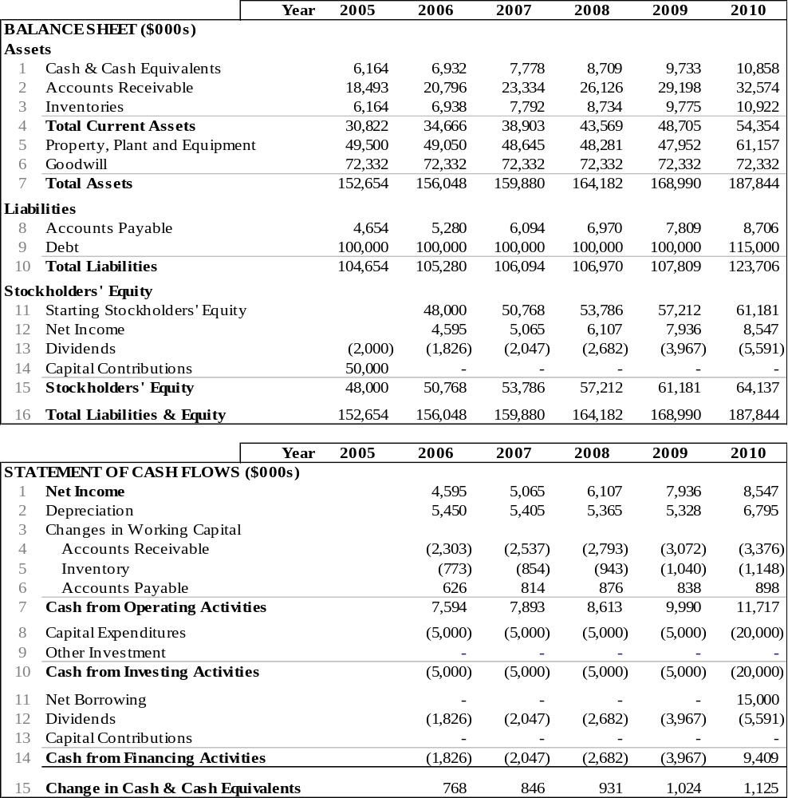
19-11. Calculate Ideko’s unlevered cost of capital when Ideko’s unlevered beta is 1.1 rather than 1.2, and all other required estimates are the same as in the chapter.
19-12. Calculate Ideko’s unlevered cost of capital when the market risk premium is 6% rather than 5%, the risk-free rate is 5% rather than 4%, and all other required estimates are the same as in the chapter.
19-13. Using the information produced in the income statement in Problem 4, use EBITDA as a multiple to estimate the continuation value in 2010, assuming the current value remains unchanged (reproduce Table 19.15). Infer the EV/sales and the unlevered and levered P/E ratios implied by the continuation value you calculated.
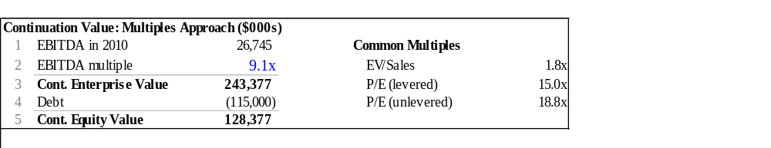
19-14. How does the assumption on future improvements in working capital affect your answer to Problem 13?
It does not affect the answer because the working capital savings do not affect EBITDA or debt levels.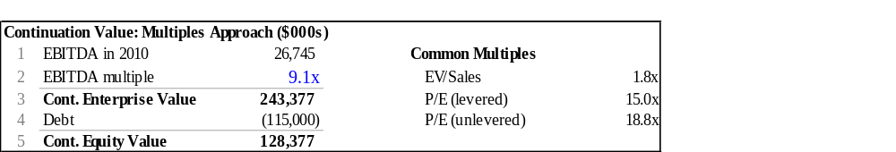
19-15. Approximately what expected future long-run growth rate would provide the same EBITDA multiple in 2010 as Ideko has today (i.e., 9.1)? Assume that the future debt-to-value ratio is held constant at 40%; the debt cost of capital is 6.8%; Ideko’s market share will increase by 0.5% per year until 2010; investment, financing, and depreciation will be adjusted accordingly; and the projected improvements in working capital occur (i.e., the assumptions in Problem 5).
Approximately 5.6%.
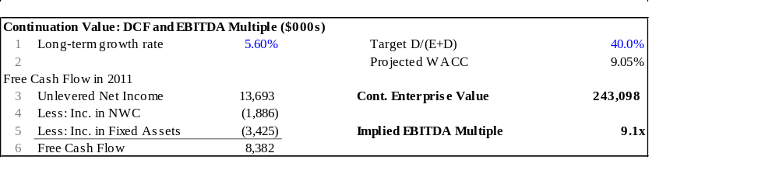
19-16. Approximately what expected future long-run growth rate would provide the same EBITDA multiple in 2010 as Ideko has today (i.e., 9.1). Assume that the future debt-to-value ratio is held constant at 40%; the debt cost of capital is 6.8%; Ideko’s market share will increase by 0.5% per year; investment, financing, and depreciation will be adjusted accordingly; and the projected improvements in working capital do not occur (i.e., the assumptions in Problem 6).
Approximately 6.05%.
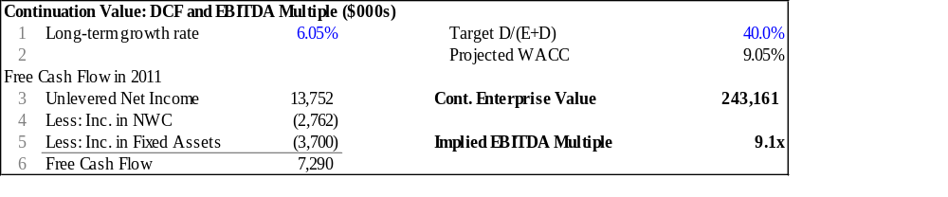
19-17. Using the APV method, estimate the value of Ideko and the NPV of the deal using the continuation value you calculated in Problem 13 and the unlevered cost of capital estimate in Section 19.4. Assume that the debt cost of capital is 6.8%; Ideko’s market share will increase by 0.5% per year until 2010; investment, financing, and depreciation will be adjusted accordingly; and the projected improvements in working capital occur (i.e., the assumptions in Problem 5).
The equity value is $90 million so the NPV of the deal is 90 – 53 = $37 million.
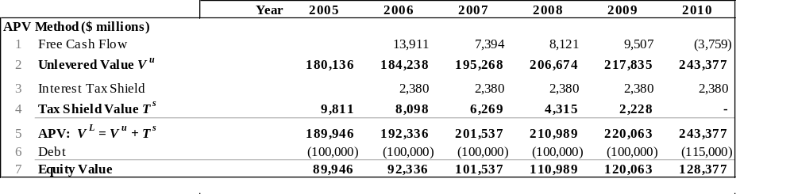
19-18. Using the APV method, estimate the value of Ideko and the NPV of the deal using the continuation value you calculated in Problem 13 and the unlevered cost of capital estimate in Section 19.4. Assume that the debt cost of capital is 6.8%; Ideko’s market share will increase by 0.5% per year; investment, financing, and depreciation will be adjusted accordingly; and the projected improvements in working capital do not occur (i.e., the assumptions in Problem 6).
The equity value is $80 million so the NPV of the deal is 90 – 53 = $27 million.
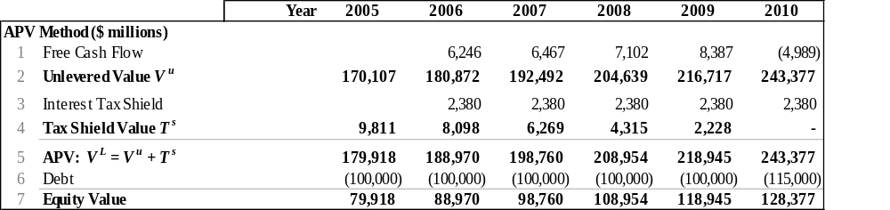
19-19. Use your answers from Problems 17 and 18 to infer the value today of the projected improvements in working capital under the assumptions that Ideko’s market share will increase by 0.5% per year and that investment, financing, and depreciation will be adjusted accordingly.
The value of the savings in working capital management is the difference between the value with and without the savings—approximately $10 million.

